
AstraQuantum Tech
Week 1 Cybersecurity Assignment
Hands-on TryHackMe Labs - Foundations of Operating Systems, the Web, and Cybersecurity Careers
Name | Muhammad Raza
Program | AstraQuantum Tech - Cybersecurity Summer Programme
Platform | TryHackMe
Rooms Completed | 5 / 5 (100%)

Table of Contents
Assignment Overview 3
Room 1: Getting Started 4
Room 2: Careers in Cyber 5
Room 3: HTTP in Detail 6
Room 4: Linux Fundamentals Part 1 9
Room 5: Windows Fundamentals Part 1 10
Conclusion 12

Assignment Overview
This report documents the completion of the Week 1 Cybersecurity Assignment issued by AstraQuantum Tech. The objective of this week's task was to build a strong foundation in cybersecurity by completing five hands-on labs on the TryHackMe platform, covering the fundamentals of operating systems, the web, and cybersecurity career paths.
Task Instructions
- Solve the Rooms: Complete all 5 assigned rooms listed below step-by-step.
- Create Documentation: For each room, a short summary/documentation is provided covering what was learned, key concepts/commands/takeaways, and screenshots of progress or completed tasks.
- Profile Tracking: The lead instructor/team profile on TryHackMe (muhammadxahmed) has been followed so activity and performance can be monitored for upcoming CTF teams.
Assigned Rooms
- Getting Started - Learn how to navigate the TryHackMe platform and get started with your first steps.
- Careers in Cyber - Explore different career domains in cybersecurity to find where your passion lies.
- HTTP in Detail - Understand how the web works under the hood by diving into HTTP requests, responses, and headers.
- Linux Fundamentals Part 1 - Learn essential Linux terminal commands and file navigation, which are core skills for any security professional.
- Windows Fundamentals Part 1 - Understand the basics of the Windows operating system and its core security features.

Room 1: Getting Started

What I Learned
Learned how to navigate the TryHackMe platform and completed my first steps.
Key Concepts, Commands, or Takeaways
- Inspecting web page source code to uncover hidden information.
- Identifying HTML comments, which begin with the <!-- character.
- Discovering hidden directories or pages (like /test-admin) left behind by developers in the source code.
- Testing common default credentials, such as admin:admin, to gain unauthorized access.
- Navigating an admin portal to extract information, such as viewing the list of signed-up users to determine the total user count.
Proof of Completion
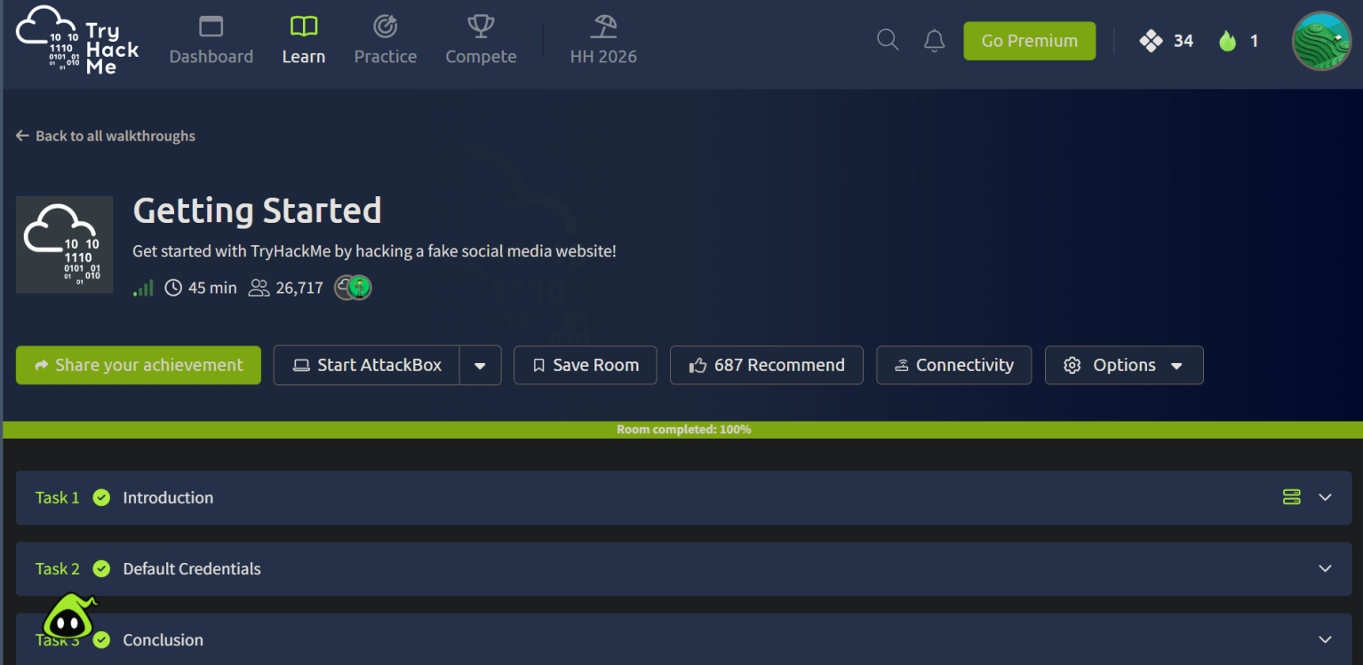

Room 2: Careers in Cyber

What I Learned
Explored a comprehensive range of career domains within the cybersecurity field to understand the landscape of industry roles and specializations.
Key Concepts, Commands, or Takeaways
- Understanding the daily responsibilities of a Security Analyst and Incident Responder, which align closely with active Blue Team operations, threat monitoring, and phishing analysis.
- Exploring the Security Engineer role, mapping directly to the design, configuration, and troubleshooting of secure, enterprise-level network topologies.
- Identifying the investigative scope of a Digital Forensics Examiner and Malware Analyst when analyzing breaches and reverse-engineering malicious code.
- Differentiating between a Penetration Tester and a Red Teamer, tying into the offensive security strategies and methodologies utilized in CTF competitions.
Proof of Completion
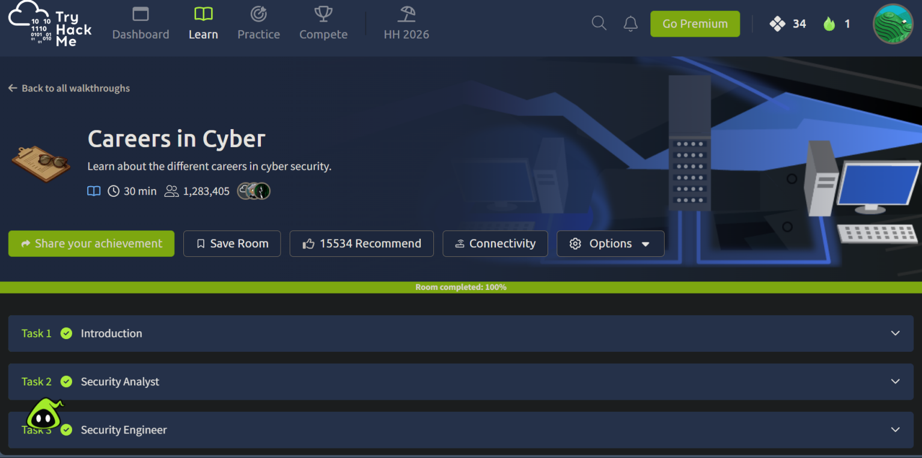

Room 3: HTTP in Detail

What I Learned
Explored how the web works under the hood by examining the structure of HTTP requests and responses, including how clients and servers communicate data securely.
Key Concepts, Commands, or Takeaways
- HTTP vs. HTTPS: Understood the basics of HyperText Transfer Protocol and the importance of the “secure” (S) certificate distinction.
- HTTP Methods: Identified the core actions used to interact with web servers: GET (viewing/retrieving data), POST (creating records), PUT (updating records), and DELETE (removing records).
- HTTP Status Codes: Learned how to interpret server responses, such as 201 (Created), 401 (Unauthorized), 404 (Not Found), and 503 (Service/Database Unavailable).
- HTTP Headers: Explored key headers that provide context to requests and responses, including Content-Length (data size), User-Agent (browser identification), Content-Type (data format), Host (requested website), and Set-Cookie (for storing session data).
- Practical Application: Successfully crafted custom requests by modifying URI parameters and body parameters (like username and password) to authenticate and manipulate endpoints.
Proof of Completion
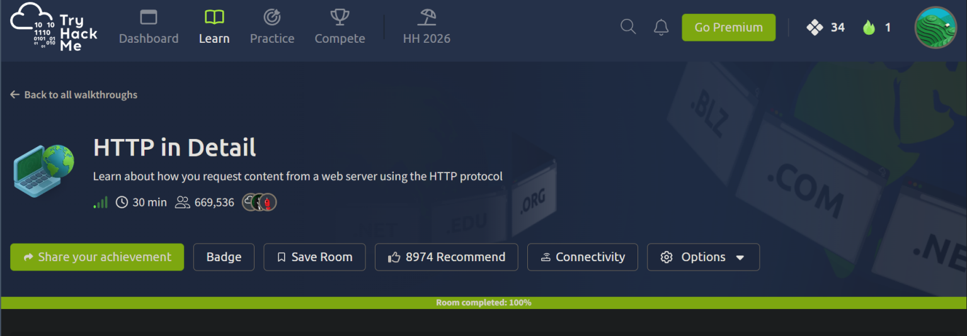

Room 4: Linux Fundamentals Part 1

What I Learned
Learned essential Linux terminal commands and file navigation techniques required to operate effectively via the command line.
Key Concepts, Commands, or Takeaways
- echo / whoami: Outputting text to the terminal using the echo command and identifying the current logged-in user with the whoami command.
- cd / pwd: Navigating the file system using cd (change directory) and determining the absolute path of the current directory using pwd (print working directory).
- grep: Searching for specific text strings or patterns within files, such as locating flags in log files, using the grep command (e.g. grep -R "PRETTY_NAME" /etc/).
- Background execution: Running commands in the background by appending the & operator.
- Redirection operators: Managing file outputs with redirection operators — using > to overwrite file contents and >> to append new data to an existing file without deleting its previous contents.
Proof of Completion
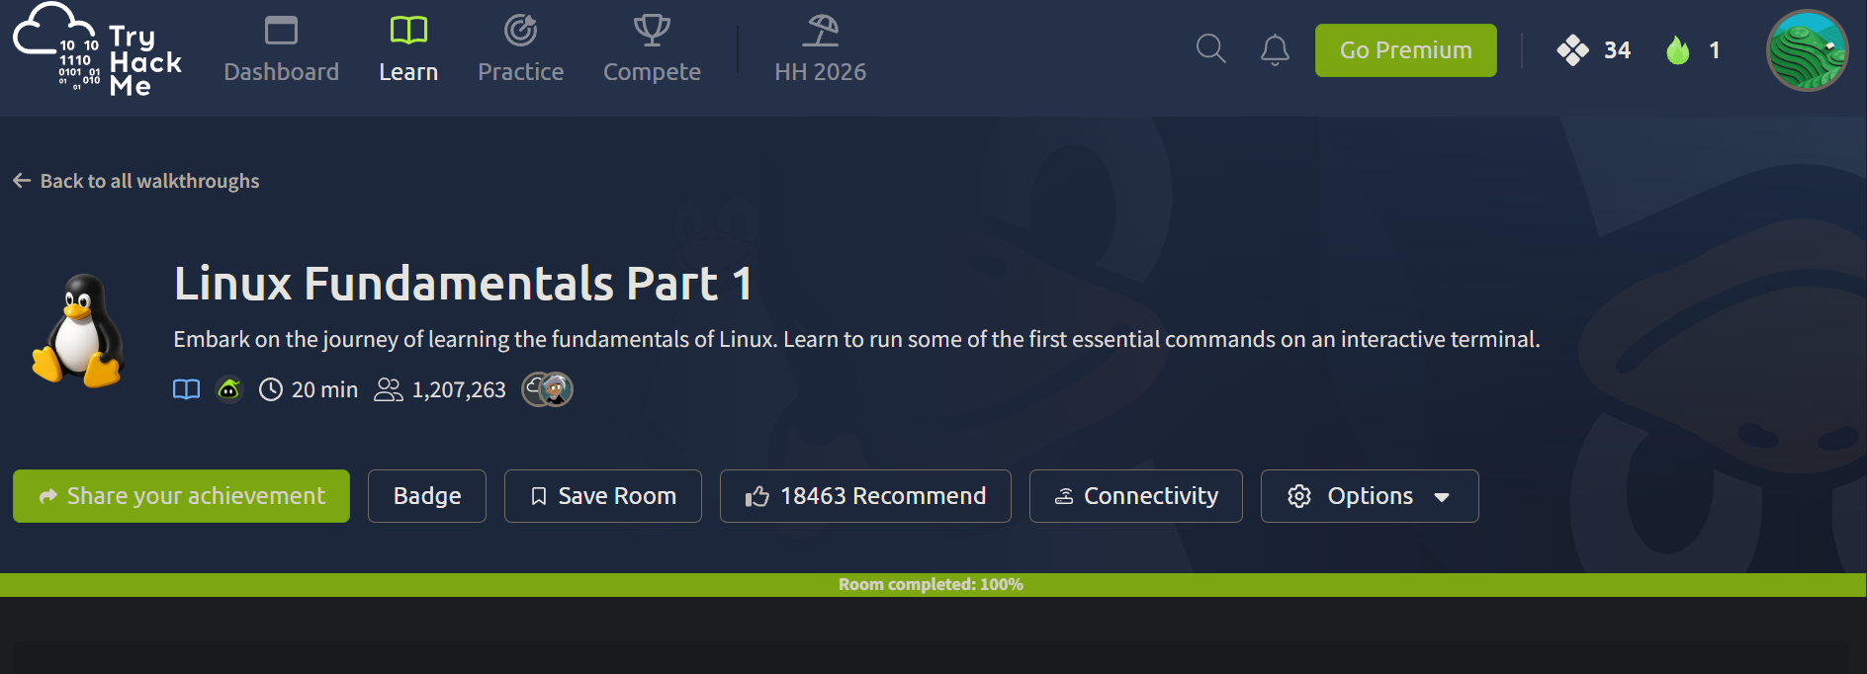

Room 5: Windows Fundamentals Part 1

What I Learned
Explored the basics of the Windows operating system, focusing on its core architecture, administrative tools, and foundational security features.
Key Concepts, Commands, or Takeaways
- Windows GUI & File System: Navigated the desktop environment and examined the underlying directory structure.
- System Architecture: Explored the Windows\System32 directory, which houses the critical executables and libraries required for the operating system to function.
- Access Management: Reviewed User Accounts, Profiles, and Permissions to understand how Windows restricts or grants access to files and system resources.
- Administrative Controls & Monitoring: Examined User Access Control (UAC) mechanisms for preventing unauthorized system changes and utilized the Task Manager for process and performance monitoring. Reviewing these specific administrative controls reinforces the foundational troubleshooting principles established in the Google IT Support Professional Certificate.
- System Configuration: Managed OS settings through the Settings app and the legacy Control Panel.
Proof of Completion
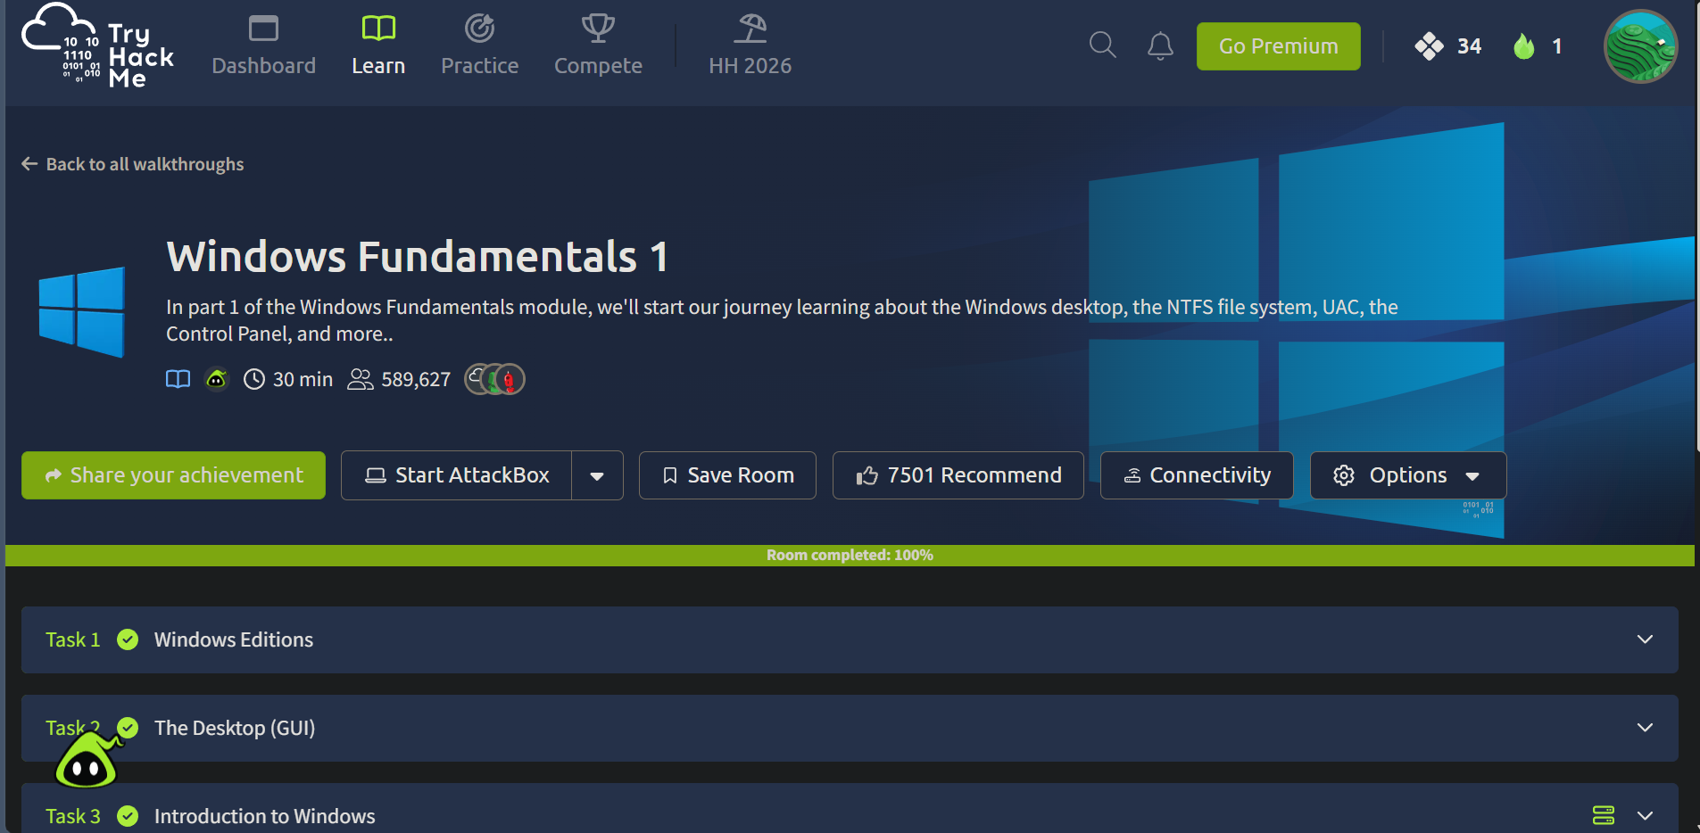

Conclusion
Over the course of Week 1, all five assigned TryHackMe rooms were completed successfully, establishing a solid foundation across three critical pillars of cybersecurity: platform fundamentals, career awareness, and core technical skills.
The Getting Started and Careers in Cyber rooms provided the orientation needed to navigate the TryHackMe platform confidently while mapping out the wide range of career paths available in the industry - from Security Analysts and Engineers to Penetration Testers and Digital Forensics Examiners. The HTTP in Detail room built a practical understanding of how web communication works, including request methods, status codes, and headers, which forms the backbone of most web application security work.
The Linux Fundamentals Part 1 and Windows Fundamentals Part 1 rooms delivered hands-on exposure to both major operating system environments used across the security field - from command-line navigation, file redirection, and text searching in Linux, to user access control, system architecture, and administrative tooling in Windows.
Together, these rooms have built the essential groundwork required for the more advanced, offensive- and defensive-security-focused labs expected in the weeks ahead. The lead instructor's TryHackMe profile has been followed as instructed for activity tracking ahead of upcoming CTF team formation.

